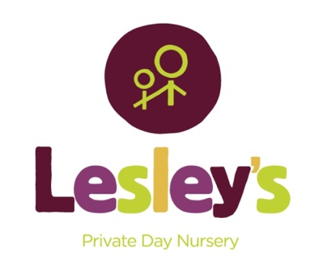

MEET
THE TEAM

This is the whole of our
staff team who work directly with the children.

Hello, my name is Lesley

Every day of my life is action packed with work, my family, the puppy and our chickens. I never seem to have a moment to myself … but I wouldn’t have it any other way!

I first started childminding just over 12 years ago and somehow that spread into the two settings we have at Mortec Park today! Even though we have very capable managers in both nurseries, I like to come in and see what is going on most days and can usually be found in my office upstairs in Unit 7. I am really proud of our staff team and how they work so hard to keep the children happy and our settings so lovely.

Hello, my name is Catherine

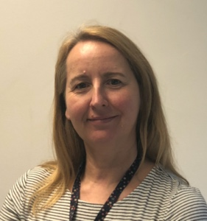
I am a Manager at Lesley’s nursery and usually work in Unit 3. I work everyday except Fridays. When I am not at Lesley’s I like to be in my garden, take long walks and go swimming. My favourite thing to do at nursery is read stories with the children and teach them Makaton!

Hello, my name is Zoë

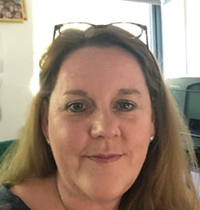
I am an Early Years Teacher and Manager at Lesley’s Nursery and usually work in Unit 7. I work everyday. Before working at Lesley’s, I worked in Harrogate at a primary school both in Reception and Nursery. I really enjoy working with the children and wanted to continue in this field. When I am not at Lesley’s I enjoy spending time with my family. We have two cats, two horses and a dog so it’s pretty busy. My favourite thing to do in nursery is teach the children. I have a passion for early years – every day is a joy to learn and teach!

Hello, my name is Michelle

I am the Deputy Manager and work 4 days a week. When I am not at Lesley’s I like to watch the Rhino’s rugby team and spend time with my granddaughter. My favourite thing to do in nursery is planning lots of exciting activities and experiences for the children.

Hello, my name is Tracey

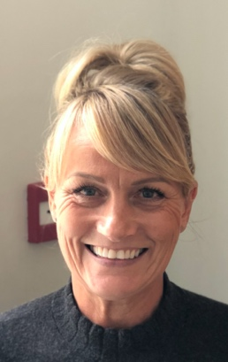
I work everyday in the office providing admin support, but I am able to spend time with the children too. When I am not at Lesley’s I like spending time with my grandchildren and socialising with family and friends. I enjoy walking, gardening and exercising. My favourite thing to do in nursery is spend time with the children. I am really lucky that I get to see them all each day, for a chat a wave, some play time or just a cuddle. They love to visit ‘Tracey’s House’ (the unit 3 office!).

Hello, my name is Abbey.

I am currently on maternity leave but will be back soon. I like to spend time with my family, friends and boyfriend going for meals, shopping and spending time in my hometown, Hull with all my family. In nursery, I like to dance to music as I used to be a dance teacher and be creative using paint and drawing. My favourite part of working with the children is their imagination and their loving nature, it’s like having a second family!

Hello, my name is Alex.

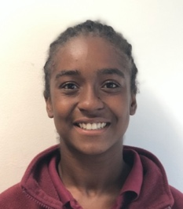
I work everyday. When I am not at Lesley’s I like to go on walks with my dog Pablo and eat out. My favourite thing to do in nursery is think of and create exciting activities for the children to do. I love to see them overcome a difficult task and the achievement on their faces when they know they can do it!

Hello, my name is Amy.

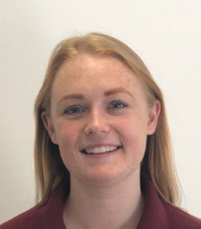
I work on a Thursday and Friday each week. When I am not at Lesley’s I like to go on adventures with my little boy and twin girls. My favourite thing to do in nursery is exploring and playing outside in the garden. I enjoy listening to the children, explaining what they have been learning and sharing stories at group time.

Hello, my name is Becky.

I work 3 days a week. When I am not at Lesley’s I like to go shopping and spend time with my family and friends. My favourite things to do in nursery are messy play, outside learning and singing with the children during circle time. I also like creating and exploring new things.

Hello, my name is Charlotte.
I work 3 days per week in nursery. When I am not in Lesley’s I like to make bath bombs and wax melts. I also love baking and cooking. My favourite things to do in nursery are messy activities such as painting and lots of other mark making activities too!

Hello, my name is Chloe (C).

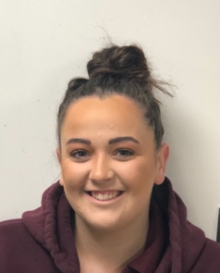
I work on Wednesday, Thursday and Friday each week. I like elephants and spending time with my nephew and family. My favourite things to do in nursery are settling the children into their rooms, giving lots of cuddles and participating in lots of messy play! I love to see the children become more confident and independent whilst at nursery.

Hello, my name is Chloe (W)

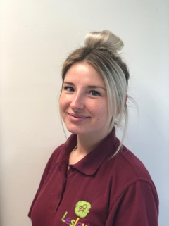
I work on Wednesday and Thursday each week. When I am not at Lesley’s I like going on fun days out with my little girl and seeing new places. My favourite things to do in nursery are exploring on walks, reading stories and making crafts. I have worked in all areas of the nursery, so it has been fun watching the children grow!

Hello, my name is Demi

I work 4 days a week in nursery. When I am not at Lesley’s I like to socialise with my friends and family. My favourite thing to do in nursery is messy play. I also love to see the children develop and learn. The best part of my day is receiving lovely cuddles from the children!

Hello, my name is Farrah

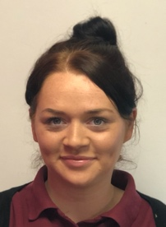
I work everyday. When I am not at nursery I like to make earrings, I love going for dog walks and socialising with my friends. My favourite thing to in nursery is yoga, wake up shake up and children’s Zumba – we love being energetic. I enjoy teaching the children phonics and number activities and playing in our nursery garden. It is important to me that the children transition around nursery with confidence.

Hello, my name is Georgia
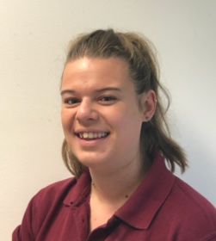
I work at nursery everyday except Fridays. When I am not at Lesley’s I like to spend time with my family and my niece. We like to go on walks and visit the seaside. My favourite things to do in nursery are lots of crafty activities and searching for fairies in the Bushcraft area.

Hello, my name is Hollie

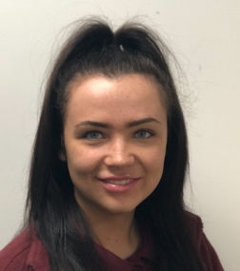
I work everyday! When I am not at Lesley’s I like to go for walks and spend time with family and friends. My favourite thing to do at nursery is full body messy play - the messier the better and going for adventure walks outside!

Hello, my name is India
I am currently attending university so you will just see me in school holidays. When I am not at Lesley’s I like painting and crafts. My favourite things to do in nursery are playing in the Bushcraft area and messy play!

Hello, my name is Jackie

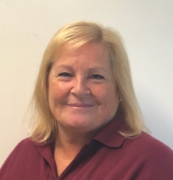
I work three days in nursery. When I am not at Lesley’s I like to grow my own plants and vegetables in my garden. I love baking and cooking too. My favourite things to do in nursery are listening to the children’s stories and chatting with them. I love doing crafts and being creative, seeing their faces when they have finished it. I also like to bake with the children too!

Hello, my name is Jake
I work everyday in nursery. When I am not at Lesley’s I like to bake. My favourite thing to do with the children is messy and outdoor play. I love reading with the children, acting out stories and singing!

Hello, my name is Jay

I work everyday at nursery. When I am not at Lesley’s I like to exercise with my friends. I am a keen football supporter and like to play and watch the games. My favourite thing to do in nursery is being outdoors with the children. I love thinking of activities to do in the Bushcraft area. I also like to sing and read books with the babies.

Hello, my name is Jessica

I work 4 days a week. When I am not at Lesley’s I like going on long walks in the Lake District and love spending time with my family and friends. My favourite thing to do with the children is reading books, and I love singing and dancing with them. I also like to do arts and crafts with the children too.

Hello, my name is Kara.
I work 3 days per week in Nursery. At the moment I am on maternity leave with my new baby boy. My favourite thing to do with the children is playing in the construction area and singing new songs.

Hello, my name is Katie.
I work 3 days per week in nursery. When I am not at Lesley’s I like to ski and be outdoors. My favourite thing to do with the children is lots and lots of messy play and singing!

Hello, my name is Kaythan.

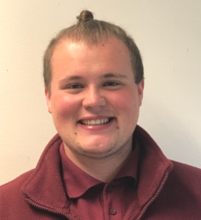
I work everyday. I have just completed my Childcare Studies degree at Leeds Trinity University and am looking to extend my studies with a Masters degree. My favourite things to do with the children are lots of messy play, singing and dancing. We love going on walks to explore the outside world too!

Hello, my name is Laura.

I work on Mondays and Wednesdays each week. When I am not at Lesley’s I enjoy walks with my family and swimming. My favourite thing to do at nursery is art and crafts. I love talking to the children about our activities and being able to extend and widen their knowledge. Role play is a favourite too, listening to their conversation and joining in with their scenarios.

Hello, my name is Lauren.

I am currently attending university. I will be back in the holidays to see you again though. When I am not at Lesley’s I like baking and going for walks with family and friends. My favourite thing to do with the children is create fun activities, get involved in lots of messy play and give hundreds of cuddles!

Hello, my name is Lucy.

I work lots of different days in nursery to fit around my university studies. When I am not in nursery I like to see my friends and family. My favourite thing to do in nursery is messy play. I love to see the children explore different textures and colours!

Hello, my name is Maddie.
I work here everyday. When I am not in nursery I like to socialise with my friends and go shopping. My favourite thing to in nursery with the children is arts, crafts and painting!

Hello, my name is Maisie.

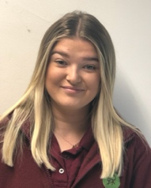
I work 4 days a week in nursery. When I am not at Lesley’s I like to spend time with family and friends on outdoor adventures. My favourite thing to do in nursery is messy play and seeing the children being creative. We love dancing and I especially like to see the children have fun whilst we are learning!

Hello, my name is Megan (B).
I work 3 days per week in nursery. When I am not at Lesley’s I like to make arts and crafts. My favourite thing to do with the children is go on walks, arts and crafts and lots of singing and reading.

Hello, my name is Megan (M)
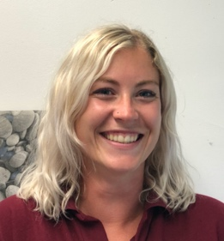
I work on Monday, Tuesday and Wednesday each week. When I am not at Lesley’s I like going on adventures with my two children. My favourite things to do in nursery with the children are playing games in the Bushcraft area and getting crafty in the messy play!

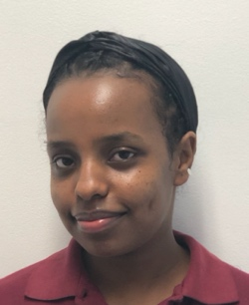
Hello, my name is Sal

I work Monday, Wednesday and Thursday. When I am not at Lesley’s I like to socialise with my friends. When I am at nursey I love to sing and dance with the children.

Hello, my name is Sarah

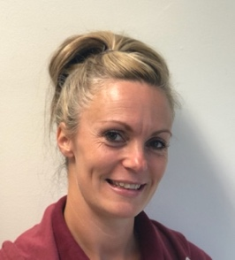
I work 4 days each week. When I am not at Lesley’s I like to go on walks, do crafts and spend time with my family and friends. My favourite thing to do in nursery is encouraging the children to join in with activities and crafts and to enjoy the outdoors. My most favourite thing is to help the children reach and achieve their goals and see them develop!

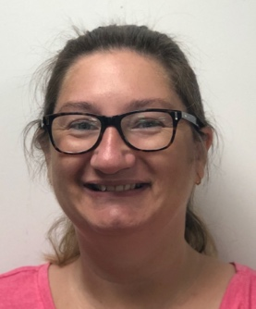
Hello, my name is Stacey

I work on Tuesday and Thursday in nursery. When I am not at Lesley’s I like to listen to music and spend time with my family. My favourite thing to do in nursery is sing nursery rhymes and read stories.

Hello, my name is Susie.

I work on Mondays and Tuesdays. When I am not at Lesley’s I enjoy spending time with my family. My favourite thing to do in nursery is work with children with additional needs, helping them develop and grow. I also enjoy learning Makaton to use with the children.

Hello, my name is Thea.
I work every Tuesday. When I am not at Lesley’s I am studying agriculture and farm management at Askham Bryan College and taking care of my horses. My favourite thing to do in Nursery is circletime and singing with the instruments.

Hello, my name is Yuri.

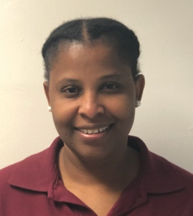
I work everyday of the week. I am originally from Portugal. I am currently completing a teaching assistant degree at Leeds University. I have two daughters and I love to cook and listen to music. My favourite thing to do in nursery is support the children with their play and learning. I also like to teach the children songs in Portuguese.

You will see our faces regularly when dropping off and collecting your child.
If you don’t see us every day, we may have been working in a different bubble or have moved to a new age group so the children get to know all of us and we get to develop our experience and knowledge across the range of ages.

